RESOURCES
‘Grief, I have learned, is really just love. It is all the love you want to give, but cannot. All that unspent love gathers up in the corners of your eyes, the lump in your throat, and that hollow part of your chest. Grief is love with no place to go.’ Jamie Anderson
- Bereavement support in time of Covid

- https://www.cruse.org.uk/get-help/coronavirus-bereavement-and-grief

- That discomfort you are feeling is grief.

- Grieving in exceptional times

- Supporting Yourself and Others - Coping with death and grief during the COVID-19 pandemic - The British Psychological Society

- https://news.sky.com/story/covid-19-bereaved-families-feel-isolated-as-they-cope-with-grief-during-the-pandemic-12143914

- https://www.irishtimes.com/life-and-style/people/grief-in-a-pandemic-not-being-able-to-see-him-in-his-final-hours-was-heartbreaking-1.4230528

- https://www.rcn.org.uk/news-and-events/blogs/reflections-on-grief-during-covid-19-from-a-personal-and-professional-perspective

- https://www.vanityfair.com/culture/2020/08/jesmyn-ward-on-husbands-death-and-grief-during-covid

HELPLINES
- CRUSE - 0808 808 1677
www.cruse.org.uk

- Samaritans (free service. available 24/7)
Call: 116 123 www.samaritans.org

- LGBT Bereavement Helpline: 0300 330 0630

- The Silver Line
0800 470 80 90
www.thesilverline.org.uk

- Bereavement Trust - National bereavement helpline. Open every evening of the year 6 pm – 10 pm. 0800 435 455

WEBSITES
- www.grief.com
- www.ataloss.org
- whatsyourgrief.com
- thegoodgriefproject.co.uk
- www.thegoodgrieftrust.org
- afterumbrage.co.uk – holidays for recently bereaved
- Grief UK - Home of Grief Recovery Method and Open Ears
- Grief during coronavirus | Marie Curie
- Pop Up Good Grief Cafes – The Good Grief Trust
- www.griefencounter.org.uk/about-us/grief-encounter-south-west/
- Coping with bereavement and coronavirus | Age UK
- widowedandyoung.org.uk Help for those under 50 who have lost a partner/spouse
- The Loss Foundation
- Coping with grief | The Loss Foundation
- Bereavement UK
- Our Online Bereavement Support - a lifeline during lockdown | Sue Ryder

BEREAVED BY SUICIDE

- https://uksobs.org Survivors of Bereaved by Suicide
BBC Three - Roman Kemp: Our Silent Emergency
Roman Kemp explores the mental health and suicide crisis affecting young men. When Roman lost his best friend, he had no idea he was struggling. Now, Roman is searching for answers.
BBC Three - Joey Essex: Grief and Me
At age ten, Joey Essex's world was ripped apart when his mum tragically took her own life. Having long buried his emotions, after 20 years can he come to terms with his grief?

CHILDREN/YOUNG ADULTS
- Child Bereavement UK
www.treehousewiltshire.org.uk
Treehouse provides bereavement support to children and young people under the age of 25 following the loss of a loved one. Includes group support (6 sessions) for children/young people aged year 7 up; called NEST. Covers Swindon and Wiltshire.

Winston’s Wish

Support for bereaved children.
08088 020 021
www.winstonswish.org

SHOUT
About Shout 85258 | Shout 85258 (giveusashout.org)
SHOUT 85258 is a free, confidential, 24/7 text messaging support service for anyone who is struggling to cope. Launched in May 2019, they have had more than 750000 conversations with people who are anxious, stressed, depressed, suicidal or overwhelmed and who need immediate support. As a digital service, Shout 85258 has become increasingly critical since Covid-19, being one of the few mental health support services able to operate as normal at this time.

APPS
Apart of Me - An app, a game, for children and young people aged 11+ who have lost a parent or other close relative, also those who have someone important in their life with a terminal illness.
https://www.apartofme.app

Grief Works –Support for Loss
The Grief Works app was created by Julia Samuel to help you navigate your grief, soothe your pain and build your strength over time. This is a guided, therapeutic course to help you manage your grief through daily activities, tools and reflections, plus in-the-moment support for managing difficult emotions whenever they arise.
‎Grief Works - Support for Loss on the App Store (apple.com)

COURSES
The Bereavement Journey
Developed at Holy Trinity Brompton, The Bereavement Journey is for anyone who has been bereaved at any time and in any way. As a series of films and discussion groups the course gently guides bereaved people through the most common aspects of grief, enabling them to process the implications for themselves and discern next steps. Usually run by churches the course uniquely offers a final session on faith questions in bereavement provided from a Christian perspective. This is optional, thus making The Bereavement Journey suitable for people of any faith or none.

TALKS
https://www.davidkesslertraining.com/Five-areas-of-grief-live-registration-thank-you?cid=39f85016-285e-4ac4-a98d-900a3a6f0d9b
https://www.davidkesslertraining.com/six-elements-video
The Adventure of Grief: Dr Geoff Warburton at TEDxBrighton - YouTube
Grief and COVID-19: Mourning What We're Missing - YouTube
Social Impact LIVE: Loss and Grief During the Coronavirus Pandemic - YouTube
How to cope with grief, fear and anxiety during Corona | Brené Brown | SVT/TV 2/Skavlan - YouTube
This pandemic erased my grief! - YouTube
How to Grieve During a Pandemic - YouTube
Good Grief, Coping with Loss: Dr Susan Delaney, Irish Hospice Foundation https://www.youtube.com/watch?v=TxSd8f2Utpk
Coping with grief | The Loss Foundation
How grief feels | Robbie Stamp | TEDxLondon - YouTube

ARTICLES
Losing my mum in lockdown was a brutal lesson in the abject loneliness of grief | Family | The Guardian
https://www.rcgp.org.uk/about-us/rcgp-blog/medical-stories-about-our-experiences-of-grief-and-loss.aspx
Guilt and Grief: Making A Living Amends - Whats your Grief
The role of guilt in grief - Care for the FamilyWhy guilt is so common after a bereavement - Counselling Directory (counselling-directory.org.uk)
UK's Covid bereaved suffer heightened grief, finds study https://www.theguardian.com/lifeandstyle/2020/nov/26/uks-26m-covid-bereaved-suffer-heightened-grief-finds-study?CMP=Share_iOSApp_Other

BOOKS
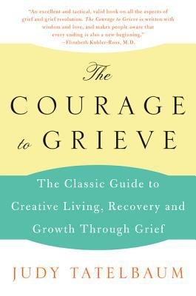

The Courage to Grieve by Judy Tatelbaum
ISBN: 0060911859
Publication Date: 2008-06-17
This unusual self-help book about surviving grief offers the reader comfort and inspiration, It provides help we need to enable us to face our grief fully and to recover and grow from the experience. Tatelbaum gives a fresh look at understanding grief, showing us that grief is a natural, inevitable human experience. The Courage to Grieve provides excellent advice on how to help oneself and others get through the immediate experience of death and the grief that follows, as well as how to understand the special grief of children.

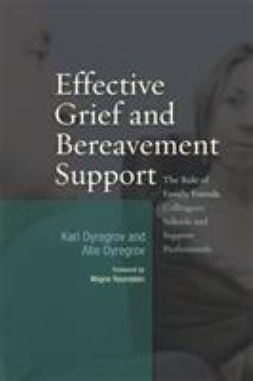

Effective Grief and Bereavement Support by Kari Dyregrov; Atle Dyregrov; Magne Raundalen (Foreword by)
ISBN: 1843106671 Publication Date: 2008-08-01 Effective Grief and Bereavement Support shows how social networks, whether they be friends, colleagues or family, can provide an important source of support following sudden bereavement. Individuals in social networks surrounding bereaved people often feel very uncertain about how best to offer support following the death of someone close. As a result of this, people often find that their relationships with friends and family suffer in the wake of bereavement. Kari and Atle Dyregrov provide concrete, evidence-based advice about how support processes can be improved. Issues covered include common reactions to grief, problems that can arise within families as a result, when to involve professional assistance, how to help bereaved children, and the main principles for effective network support.

Good Grief by Granger E. Westberg
ISBN: 0800697812
Publication Date: 2010-10-01
Good Grief identifies ten stages of grief—shock, emotion, depression, physical distress, panic, guilt, anger, resistance, hope, and acceptance—but, recognizing that grief is complex and deeply personal, defines no "right" way to grieve. Good Grief offers valuable insights on the emotional and physical responses people might experience during the natural process of grieving. Whether mourning the death of a loved one, the end of a marriage, the loss of a job, or other difficult life changes, Good Grief is a proven steady companion in times of loss.

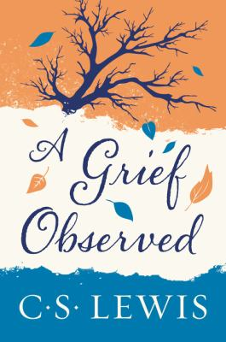

A Grief Observed by C. S. Lewis; Madeleine L'Engle (Foreword by)
ISBN: 0060652381
Publication Date: 2015-04-21
A classic work on grief, A Grief Observed is C.S. Lewis’s honest reflection on the fundamental issues of life, death, and faith in the midst of loss. Written after his wife’s tragic death as a way of surviving the “mad midnight moments,” A Grief Observed an unflinchingly truthful account of how loss can lead even a stalwart believer to lose all sense of meaning in the universe, and the inspirational tale of how he can possibly regain his bearings.

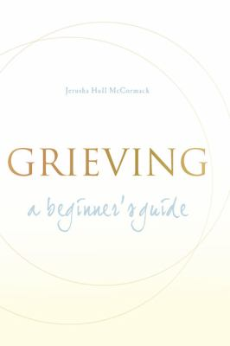

Grieving by Jerusha Hull McCormack
ISBN: 1557254931
Publication Date: 2006-03-01
There is no sure route through grieving. Jerusha McCormack provides instead a series of signposts by which we may find our own path to a new life. "We are all amateurs at grief," she writes, "it comes to us all; we must all go through it. To treat grief as a problem to be fixed, or (worse still) to medicalize it, is to rob us of the extraordinary privilege of encountering this experience on our terms: for each of us has our own way of grieving, and each of us has something special to learn from the process."

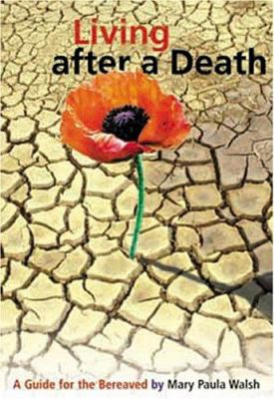

Living after a Death by Mary Paula Walsh
ISBN: 1853905607
Publication Date: 2005-03-01
An Irish publication which provides a guide to the grieving process. Its five sections outline how to address the pain of grief, offer advice for specific types of bereavement and encouragement for moving beyond grief.

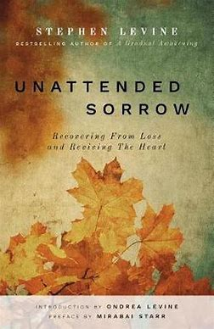
Unattended Sorrow by Stephen Levine
Publisher: Monkfish Book Publishing; 2nd edition (26 Feb. 2019)
ISBN-10: 1939681901
ISBN-13: 978-1939681904
Wise and compassionate advice to help heal emotional wounds that linger and prevent us from leading full and happy lives. Unattended sorrow is unresolved grief that has never been given a chance to heal. This lovely, spiritual book from one of the nation's most trusted grief counsellors offers a series of techniques to help heal this pain so readers can lead full and joyful lives. The book not only guides those who have experienced a fresh loss to face the hurt before it settles in, but it also addresses the devastating impact of tragedies past….

PODCASTS
What's Your Grief Podcast?
Grief Support for Those Who Like to Listen By Eleanor Haley & Litsa Williams
Mental health professionals Eleanor Haley and Litsa Williams, the team behind the 'What's Your Grief' website examine grief in all its forms. The podcast is suitable for grievers and grief professionals.
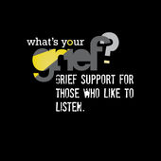
Grief Cast Podcast
Hosted by comedian Cariad Lloyd this podcast features comedians talking about their own experiences of death and grief. The podcast combines intimate honest personal stories with humour.
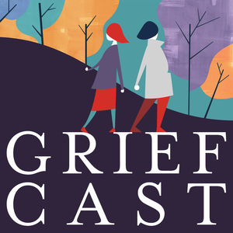

Grief Works Podcasts
Grief Works Podcast by Julia Samuel
This podcast is hosted by Julia Samuel, a grief psychotherapist with over twenty five years’ experience. In each episode a bereaved person talks about their experience of loss and how they cope with bereavement.
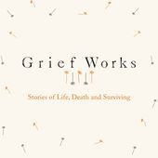

Terrible, (thanks for asking)
Podcast hosted by Nora McInerny, a self-described 'notable widow'. The podcast talks honestly (and with humour) about our pain and loss, see also her TED Talk, link below.
- Grief is my superpower - Apple
- The Bereavement Room - Apple
- You, me and the big C – BBC Sounds
Stuff You Should Know - Grief Episode
An episode of the popular podcast 'Stuff You Should Know' focusing on the science and processes of grief and grieving.
Videos and films
Do Bereaved people need counselling? - Susan Delaney
After Life - | Netflix Official Site
We don't "move on" from grief. We move forward with it | Nora McInerny - YouTube

Articles:

Our Experience of Grief is Unique as a Fingerprint

David Kessler on the Difference Between Mourning and Grief - By David Kessler

November 15, 2019
For the dead and the living, we must bear witness.
–Elie Wiesel
Each person’s grief is as unique as their fingerprint. But what everyone has in common is that no matter how they grieve, they share a need for their grief to be witnessed. That doesn’t mean needing someone to try to lessen it or reframe it for them. The need is for someone to be fully present to the magnitude of their loss without trying to point out the silver lining.
This need is hardwired in us, since our emotions bind us to one another, and in those bonds is the key to our survival. From the moment we’re born, we realize we’re not alone. Our brains are equipped with mirroring neurons, which is why when the mother smiles, the baby smiles back. This continues into adulthood. I remember walking down the street one day and a man said to me, “Howdy.” I’m not usually someone who says “Howdy.” But I instinctively said back to him, “Howdy!” This is more than copying each other’s expressions. It’s also about the emotions underlying the expressions. The mirroring neurons enable mother and child to pick up on each other’s emotions.Dr. Edward Tronick is part of a psychology team that made a short video that shows what happens if babies do not feel their emotions reflected and acknowledged by those around them. First we see a ten-month-old sitting in a high chair, eyes wide and happily fixed on his mother’s smiling face. The baby and mother mirror each other as I described above. One laughs, then the other laughs; the baby points and the mother looks in the direction in which he’s pointing. But then at the direction of the researchers, the mother turns away, and when she turns back to the baby, she has a blank look on her face. The confused baby does everything to try to get a reaction out of her. He cries and screams in distress. This is an innate reaction, because children know on a subconscious level that they need others for survival. If their survival is dependent on someone who is unable to be truly present for them, they suffer.
The same is true for adults. If they are grieving, they need to feel their grief acknowledged and reflected by others. But in our hyper busy world, grief has been minimized and sanitized. You get three days off work after a loved one dies and then everyone expects you to carry on like nothing happened. There are fewer and fewer opportunities for those around you to bear witness to your pain, and this can be very isolating.
I was touring in Australia when I met a researcher who told me about the work she was doing to study the way of life in the northern indigenous villages of Australia. One of the villagers told her that the night someone dies, everyone in the village moves a piece of furniture or something else into their yard. The next day, when the bereaved family wakes up and looks outside, they see that everything has changed since their loved one died—not just for them but for everyone. That’s how these communities’ witness, and mirror, grief. They are showing in a tangible way that someone’s death matters. The loss is made visible.
In this country, too, it was once common for us to come together as a community to bear witness to the grief experienced when a loved one died. But in our current culture, the mourner is made to feel that though his or her own world has been shattered, everyone else’s world goes on as if nothing has changed. There are too few rituals to commemorate mourning, and too little time allotted to it.
Grief should unite us. It is a universal experience. If I’m talking to someone with a physical ailment, I can listen and empathize, but I may never have that particular problem. When I’m with someone whose loved one died, however, I know I’ll be in their shoes someday and I try to understand what they are feeling. Not to change it—just to acknowledge it fully. I feel privileged when someone shares their pain and grief with me. The act of witnessing someone’s vulnerability can bring the person out of isolation if the witnessing is done without judgment.
Grief is what’s going on inside of us, while mourning is what we do on the outside.
Too often outsiders who may have the best of intentions will suggest to a bereaved person that it’s time to move on, embrace life, and let go of grief. But grief should be a no-judgment zone. Those who understand what you’re going through will never judge you or think your grief is out of proportion or too prolonged. Grief is what’s going on inside of us, while mourning is what we do on the outside. The internal work of grief is a process, a journey. It does not have prescribed dimensions and it does not end on a certain date.
When people ask me how long they’re going to grieve, I ask them, “How long will your loved one be dead? That’s how long. I don’t mean you’ll be in pain forever. But you will never forget that person, never be able to fill the unique hole that has been left in your heart. There is what I call the one-year myth—we should be done and complete with all grieving in one year. Not remotely true. In the first year of your loss, you’re likely to mourn and grieve intensely. After that, your grief will probably fluctuate. It will seem to lessen, then something will trigger it, and you’ll find yourself back in the full pain of loss. In time it will hurt less often and with less intensity. But it will always be there.”
That’s about as specific as I can get in answering the question. As vague as it is, it still doesn’t cover all the possibilities. Over many years of grief work, I’ve come to realize that if I’ve seen one person in grief, I’ve only seen that one person in grief. I can’t compare one griever to another, even if they’re in the same family. One sister cries a lot and the other one doesn’t. One son is vulnerable and raw. The other just wants to move on. Some people are expressive. Others shy away from their feelings. Some have more feelings. Some have less. Some are more productive and practical in their grieving style. They have a “buckle down and move on” mentality. We can mistakenly think that people who show no visible signs of pain should be in a grief group, getting in touch with and sharing their feelings. But if that is not their style in life, it won’t be in grief, either. They must experience loss in their own way. Suggesting otherwise will not be helpful to them.
In our modern world, our grief is often witnessed online. When I post quotes about grief on social media, I notice different kinds of responses. If I post hopeful, optimistic quotes about healing, they give hope to many people, but don’t resonate with others. Those who are in a dark place aren’t ready to hear about hope, often because they’re at the beginning of the grieving process and their grief is too acute to allow for any other emotions. They just want the darkness of their grief to be seen and acknowledged. Their tears are evidence of their love, proof that the person who died was someone who mattered deeply. If I post something like, “Today it feels like the pain will never end,” or “Grief feels like a dark cloud that encompasses the whole sky,” that will resonate with them. It mirrors and validates their feelings, which can be far more consoling than trying to find something positive in the situation.
Some grieve with darkness, some with light, some with both, depending on where they are in the cycle of grief. It would be a mistake to conclude that one is better than the other or that there’s a right way to grieve. There are just different ways to grieve, different feelings evoked by loss. This is also true of our relationship to hope. Hope can be like oxygen to people in grief. For others, however, especially in the early stages, it can feel invalidating. “In my sorrow, how dare you want me to feel hopeful . . . about what? Do you need me to hope to make you feel more comfortable?”
Hope has a very close relationship with meaning. In the same way our meaning changes, so does hope. Sometimes when I work with someone stuck in grief, I will say, “It sounds like hope died with your loved one. It seems all is lost.”
Surprisingly they perk up. “Yes, that’s it.”
They feel witnessed. I often say, “A loved one’s death is permanent, and that is so heartbreaking. But I believe your loss of hope can be temporary. Until you can find it, I’ll hold it for you. I have hope for you. I don’t want to invalidate your feelings as they are, but I also don’t want to give death any more power than it already has. Death ends a life, but not our relationship, our love, or our hope.”
Sometimes I meet someone in grief who tells me that a family member or friend said something terrible—which often turns out to be some variation of “time heals all” or “be happy your loved one is at peace now.” Such statements can make the bereaved think that their feelings have not been witnessed. Most of us want to say something helpful, but we may not realize that our timing and delivery are off. If the griever needs to remain in a dark place for a while, then trying to offer some kind of cheer will be very hurtful. We must really see the person we are trying to comfort. Loss can become more meaningful—and more bearable—when reflected, and reflected accurately, in another’s eyes.
We also have to remember that our own thoughts about the one who died are irrelevant. Maybe we think our friend’s mother was so awful that she wasn’t worth grieving over. Or we know that our sister’s husband had been unfaithful and wonder why she is nonetheless sobbing over his death. What we think has nothing at all to do with the feelings of those who are in grief, and they will not be comforted by hearing us criticize their loved ones as not being deserving of their sorrow.
People who mourn the loss of their pets often comment on how little people understand about their grief. In the months that followed the death of my son, one of my dear friends experienced his own loss. His beloved dog died at the age of 16. When I reached out to him to express my condolences, he was taken aback by my concern. “Your loss is so much worse than mine,” he said. I couldn’t see his tears and think that his loss was any less painful or meaningful than mine. Every loss has meaning, and all losses are to be grieved—and witnessed. I have a rule on pet loss. “If the love is real, the grief is real.” The grief that comes with loss is how we experience the depths of our love, and love takes many forms in this life.

Myths about grief.
There are five stages of grief that follow a linear pattern.
Since Dr. Kubler-Ross published her book On Death and Dying in 1968,¹ her idea of the five stages of grief has circled the globe and has found its way into many different cultures. The stages are denial, anger, bargaining, depression, and acceptance. However, Kubler-Ross based her findings on interviews with the dying, not the bereaved. She felt they represented how those who were facing an imminent death coped. It was quickly applied to the grieving as well. Initially, people believed that once you went through all the stages and reached acceptance, grief was over. However, what we know now about grief is that our thoughts and emotions vacillate, and not just in a day, but in an hour or a minute. There really is no right or wrong way to grieve. No purpose is served by comparing how you grieve and what you do to another, even with the same type of loss.

Grief has an endpoint.

Grief may change over time, there may be darker days and lighter days, there may be detours along the path…but there is no end to the journey, there is no destination.

Once you are done grieving, life will return to “normal”.

Life will not be as it was before your loss. Life will continue to change, as you will continue to change….that is the nature of this experience we call life…constant change. Grieving is an ongoing process and hopefully in that process you will learn how to be with the new “normal”.
There is a consistent and predictable timeline for grief.
This is such an unhelpful myth. At the very essence of grief is inconsistency and unpredictably and anyone who tells you otherwise should be ignored.

The first year is the worst.

For some people this is true; for others it is not true. This is sort of the point with grief….there are no rules. Each person’s experience of loss and grief is unique to them and there is no right or wrong way to grieve.

You recover from grief like you recover from a cold, it gets a little better every day until it completely goes away.

Grief is not an illness from which you recover, and it never completely goes away. With time it’s power may diminish and life may feel easier, but it is not a linear process and it is not something to be “cured”.

If you are still talking about your loved one after ____ years it means you’re “stuck”.

False and simplistic.

If you still display photos of your loved one after ____ years it means you’re “stuck”.

False and simplistic.

If you haven’t gotten rid of your loved one’s belongings after ____years it means you’re “stuck”.

False and simplistic.

If you still cry when you think/talk about your loved one after ____ years it means you’re “stuck”.

False and simplistic.

Women grieve more than men.

Just plain false.

Your friends and family will always be the best support.

They may be very supportive…they may not…ridiculously unhelpful statement!

If you aren’t crying, then you aren’t grieving.

People grieve and express their grief in a myriad of ways. Some cry, some don’t. Some scream and shout, some don’t. Some overwork, some can’t get out of bed in the morning. Some sleep all the time, some can’t sleep. Some eat more, some can’t face food. And on and on.

Grieving is a problem.

Grieving is NOT a problem, it is a human experience which speaks of the love we feel for someone. Grief is the price we pay for loving, but it is not a problem to be solved. There is no solution…there is just feeling it.

You grieve less when the person who died is older and “lived a long life”.

There is no hierarchy of grief.

People don’t grieve after a miscarriage in the same way they grieve other deaths.

Again, there is no hierarchy of grief. There is no less or more, no right or wrong. There is just grief.

